SYSTEM DESIGN

UML DIAGRAMS
The System Design Document describes the system requirements, operating environment, system and subsystem architecture, files and database design, input formats, output layouts, human-machine interfaces, detailed design, processing logic, and external interfaces.

Global Use Case Diagrams:
Identification of actors:
Actor: Actor represents the role a user plays with respect to the system. An actor interacts with, but has no control over the use cases.
Graphical representation:

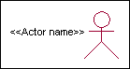
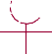

<<Actor name>>
Actor

An actor is someone or something that:
Interacts with or uses the system.
Provides input to and receives information from thesystem.
Is external to the system and has no control over the use cases. Actors are discovered by examining:
- Who directly uses thesystem?
- Who is responsible for maintaining thesystem?
- External hardware used by thesystem.
- Other systems that need to interact with the system. Questions to identifyactors:
- Who is using the system? Or, who is affected by the system? Or, which groups need help from the system to perform atask?

- Who affects the system? Or, which user groups are needed by the system to perform its functions? These functions can be both main functions and secondary functions such asadministration.
- Which external hardware or systems (if any) use the system to perform tasks?
- What problems does this application solve (that is, forwhom)?
- And, finally, how do users use the system (use case)? What are they doing with thesystem?
The actors identified in this system are:

System Administrator
- Customer

CustomerCare
Identification of usecases:
Usecase: A use case can be described as a specific way of using the system from a user’s (actor’s)perspective.

Graphical representation:
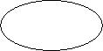

A more detailed description might characterize a use case as:
- Pattern of behavior the systemexhibits
- A sequence of related transactions performed by an actor and thesystem
- Delivering something of value to the actor Use cases provide a meansto:
- capture systemrequirements
- communicate with the end users and domainexperts
- test thesystem
Use cases are best discovered by examining the actors and defining what the actor will be able to do with thesystem.
Guide lines for identifying use cases:

- For each actor, find the tasks and functions that the actor should be able to perform or that the system needs the actor to perform. The use case should represent a course of events that leads to clear goal
- Name the usecases.
- Describe the use cases briefly by applying terms with which the user isfamiliar. This makes the description lessambiguous
Questions to identify use cases:
- What are the tasks of eachactor?
- Will any actor create, store, change, remove or read information in thesystem?
- What use case will store, change, remove or read thisinformation?
- Will any actor need to inform the system about sudden externalchanges?
- Does any actor need to inform about certain occurrences in thesystem?
- What usecases will support and maintains thesystem?

Flow of Events
A flow of events is a sequence of transactions (or events) performed by the system. They typically contain very detailed information, written in terms of what the system should do, not how the system accomplishes the task. Flow of events are created as separate files or documents in your favorite text editor and then attached or linked to a use case using the Files tab of a model element.
A flow of events should include:
- When and how the use case starts andends
- Use case/actorinteractions
- Data needed by the usecase
- Normal sequence of events for the usecase
- Alternate or exceptional flows Construction of Usecasediagrams:
Use-case diagrams graphically depict system behavior (use cases). These diagrams present a high level view of how the system is used as viewed from an outsider’s (actor’s) perspective. A use-case diagram may depict all or some of the use cases of asystem.
A use-case diagram can contain:

- actors ("things" outside thesystem)

- use cases (system boundaries identifying what the system should do)
- Interactions or relationships between actors and use cases in the system including the associations, dependencies, andgeneralizations. Relationships in use cases:

Communication:
The communication relationship of an actor in a usecase is shown by connecting the actor symbol to the usecase symbol with a solid path. The actor is said to communicate with the usecase.

Uses:
A Uses relationship between the usecases is shown by generalization arrow from the usecase.

Extends:
The extend relationship is used when we have one usecase that is similar to another usecase but does a bit more. In essence it is like subclass.

SEQUENCE DIAGRAMS
A sequence diagram is a graphical view of a scenario that shows object interaction in a time- based sequence what happens first, what happens next. Sequence diagrams establish the roles of objects and help provide essential information to determine class responsibilities and interfaces. There are two main differences between sequence and collaboration diagrams: sequence diagrams show time-based object interaction while collaboration diagrams show how objects associate with each other. A sequence diagram has two dimensions: typically, vertical placement represents time and horizontal placement represents differentobjects.

Object:
An object has state, behavior, and identity. The structure and behavior of similar objects are defined in their common class. Each object in a diagram indicates some instance of a class. An object that is not named is referred to as a class instance.
The object icon is similar to a class icon except that the name is underlined: An object's concurrency is defined by the concurrency of its class.

Message:
A message is the communication carried between two objects that trigger an event. A message carries information from the source focus of control to the destination focus of control. The synchronization of a
message can be modified through the message specification. Synchronization means a message where
the sending object pauses to wait forresults.

Link:
A link should exist between two objects, including class utilities, only if there is a relationship between their corresponding classes. The existence of a relationship between two classes symbolizes a path of communication between instances of the classes: one object may send messages to another. The link is depicted as a straight line between objects or objects and class instances in a collaboration diagram. If an object links to itself, use the loop version of the icon.

CLASS DIAGRAM:
Identification of analysis classes:
A class is a set of objects that share a common structure and common behavior (the same attributes, operations, relationships and semantics). A class is an abstraction of real-world items. There are 4 approaches for identifying classes:
    - Noun phrase approach:
    - Common class patternapproach.
    - Use case Driven Sequence or Collaborationapproach.
    - Classes , Responsibilities and collaboratorsApproach

Noun PhraseApproach:
The guidelines for identifying the classes:
- Look for nouns and noun phrases in the usecases.
- Some classes are implicit or taken from generalknowledge.
- All classes must make sense in the application domain; Avoid computer implementation classes – defer them to the designstage.
- Carefully choose and define the class names After identifying the classes we have to eliminate the following types ofclasses:

- Adjectiveclasses.

Common class patternapproach:
The following are the patterns for finding the candidate classes:
- Conceptclass.
- Eventsclass.
- Organizationclass
- Peoplesclass
- Placesclass
- Tangible things and devicesclass.

Use case drivenapproach:
We have to draw the sequence diagram or collaboration diagram. If there is need for some classes to represent some functionality then add new classes which perform those functionalities.

CRCapproach:
The process consists of the following steps:
- Identify classes’ responsibilities ( and identify the classes)
- Assign theresponsibilities
- Identify the collaborators. Identification of responsibilities of eachclass:
The questions that should be answered to identify the attributes and methods of a class respectively are:
        - What information about an object should we keep trackof?
        - What services must a class provide? Identification of relationships among theclasses:
Three types of relationships among the objects are: Association: How objects are associated?
Super-sub structure: How are objects organized into super classes and sub classes? Aggregation: What is the composition of the complex classes?
Association:
The questions that will help us to identify the associations are:
- Is the class capable of fulfilling the required task byitself?
- If not, what does itneed?
- From what other classes can it acquire what itneeds? Guidelines for

identifying the tentativeassociations:
- A dependency between two or more classes may be an association. Association often corresponds to a verb or prepositionalphrase.
- A reference from one class to another is an association. Some associations are implicit or taken from generalknowledge.
Some common association patterns are:
Location association like part of, next to, contained in….. Communication association like talk to, order to ……
We have to eliminate the unnecessary association like implementation associations, ternary or n- ary associations and derived associations.
Super-sub class relationships:
Super-sub class hierarchy is a relationship between classes where one class is the parent class of another class (derived class).This is based on inheritance.
Guidelines for identifying the super-sub relationship, a generalization are

Top-down:
Look for noun phrases composed of various adjectives in a class name. Avoid excessive refinement. Specialize only when the sub classes have significant behavior.

Bottom-up:
Look for classes with similar attributes or methods. Group them by moving the common attributes and methods to an abstract class. You may have to alter the definitions a bit.

Reusability:
Move the attributes and methods as high as possible in the hierarchy.

Multipleinheritances:
Avoid excessive use of multiple inheritances. One way of getting benefits of multiple inheritances is to inherit from the most appropriate class and add an object of another class as an attribute.

Aggregation or a-part-of relationship:
It represents the situation where a class consists of several component classes. A class that is composed of other classes doesn’t behave like its parts. It behaves very difficultly. The major properties of this relationship

are transitivity and antisymmetry.
The questions whose answers will determine the distinction between the part and whole relationships are:
- Does the part class belong to the problemdomain?
- Is the part class within the system’sresponsibilities?

- Does the part class capture more than a single value?( If not then simply include it as an attribute of the wholeclass)
- Does it provide a useful abstraction in dealing with the problemdomain? There are three types of aggregation relationships. Theyare:

Assembly:
It is constructed from its parts and an assembly-part situation physically exists.

Container:
A physical whole encompasses but is not constructed from physical parts.

Collection member:
A conceptual whole encompasses parts that may be physical or conceptual. The container and collection are represented by hollow diamonds but composition is represented by solid diamond.

USE CASE DIAGRAM
A use case diagram in the Unified Modeling Language (UML) is a type of behavioral diagram defined by and created from a Use-case analysis. Its purpose is to present a graphical overview of the functionality provided by a system in terms of actors, their goals (represented as use cases), and any dependencies between those use cases. The main purpose of a use case diagram is to show what system functions are performed for which actor. Roles of the actors in the system can be depicted.
Start
Upload data
Reading Data
Train test split
Exit
All Classifiers
Model Comparison
User
Prediction

CLASS DIAGRAM
In software engineering, a class diagram in the Unified Modeling Language (UML) is a type of static structure diagram that describes the structure of a system by showing the system's classes, their attributes, operations (or methods), and the relationships among the classes. It explains which class contains information.

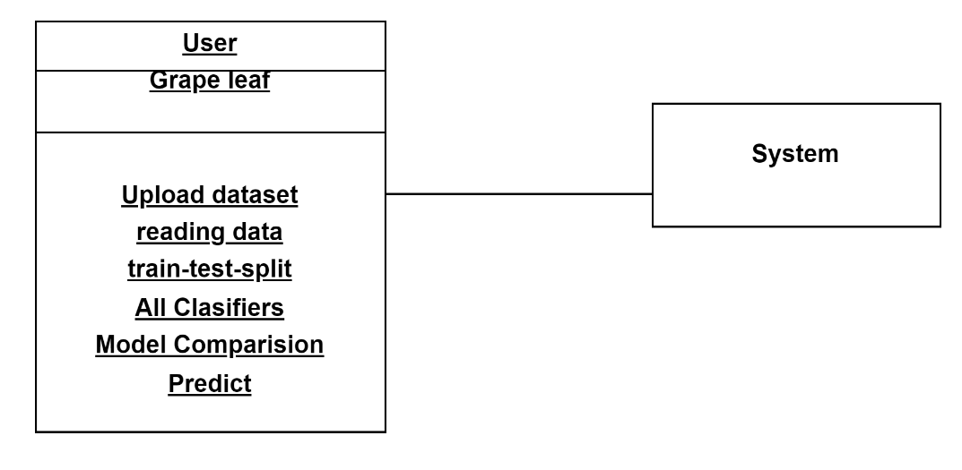

SEQUENCE DIAGRAM
A sequence diagram in Unified Modeling Language (UML) is a kind of interaction diagram that shows how processes operate with one another and in what order. It is a construct of a Message Sequence Chart. Sequence diagrams are sometimes called event diagrams, event scenarios, and timing diagrams.

User
System
Start
Upload Data
Reading Data

Train- test-Split
All Classifiers
Model Comparisions
Predict
Exit

